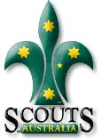
Cub Kit / Inspection

Each week at the start of Cubs, we have Inspection. Cubs who pass inspection get a 'bone', which counts towards points for their Six. Part of inspection is that each Cub is supposed to have their 'Kit' with them. With a number of new Cubs joining, I thought it appropriate to remind them in writing, so that they can remember it.....

The kit can be either kept in a shirt pocket, or else in a belt pouch if one is purchased from Snowgum (this is totally optional).

It should consist of:

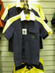
- Yellow Badge Book
- Notepad
- Pencil (shortened to fit)
- Money for a public phone
- Band-Aid
- Safety pins

ALSO, during inspection, we check for:

- Paws, Fangs & Fur (clean hands, teeth, and tidy hair)
- Scarfs rolled and worn correctly with woggle
- Proper uniform
- Shirt tucked in
- & last but not least…. A smile!
☺

Regards

The Leaders

