Banyule District
Cub Scouts
Annual District SWIMMING NIGHT
On Friday the 22nd of August

Our District Swimming Nights are lots of fun!
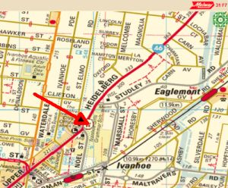

We will be meeting at 6.45
Finishing around 8.30pm

Meet at the Ivanhoe Girls School Swimming Pool,
Lower Heidelberg Road, Ivanhoe
(Melway 31 F7
– over the road from the Ivanhoe Centre – Town Hall)

Cost covered by District

You will be able to work on your Level 1 or Level 2 Swimming Badge (Yellow Badge Book, p136-137)

NOTE: If you want to try for the level 2 badge, you must bring shorts and shirt to put on over your bathers and swim in.

Any queries, contact Akela

 | Wayne Renfrew, Akela - Rosanna Cubs
 | ph: | (03) 9434 7594 or 0411 121 495
 | email: | akela@rosannacubs.org
 | See us at: | www.rosannacubs.org

