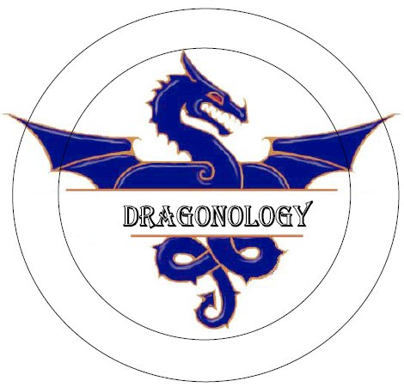

Rosanna Cubs
Next Week – Dragonology!

…..don’t forget – it’s MONDAY NIGHT – 17th!

Time to close off Term 3 and the first 6 months of our brand new Cub Pack.

Come along and learn how we hunt for ….. DragonS
Dress up as a dragon hunter, or even a dragon if you like (just remember you need to be mobile for our games and activities!) and join in:

Dragonology!

NEXT MONDAY, SEPTEMBER 17th – BE THERE!



Regards

 | Akela - Rosanna Cubs
 | ph: | (03) 9434 7594 or 0411 121 495
 | email: | akela@rosannacubs.org
 | See us at: | www.rosannacubs.org

