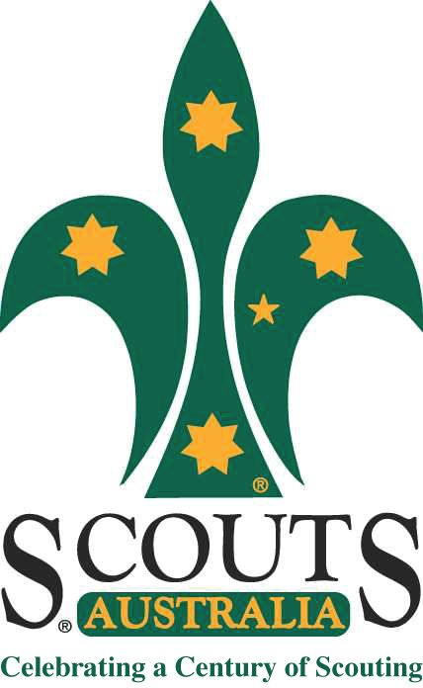
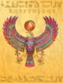
Rosanna Cubs
EGYPTOLOGY!

TUESDAY - 16th Sep!

Time to close off Term 4 and have tons of fun!

Come along and learn how to be an ….. Egyptologist

Dress up as a an Egyptian or an Egyptologist (just remember you need to be mobile for our games and activities!) and join in:
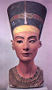
Egyptology!
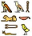

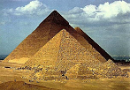
TUESDAY, SEPTEMBER 16th – BE THERE!

Regards

 | Wayne Renfrew, Akela - Rosanna Cubs
 | ph: | (03) 9434 7594 or 0411 121 495
 | email: | akela@rosannacubs.org
 | See us at: | www.rosannacubs.org

Excerpts from “Egyptology” by The Five Mile Press Pty Ltd

