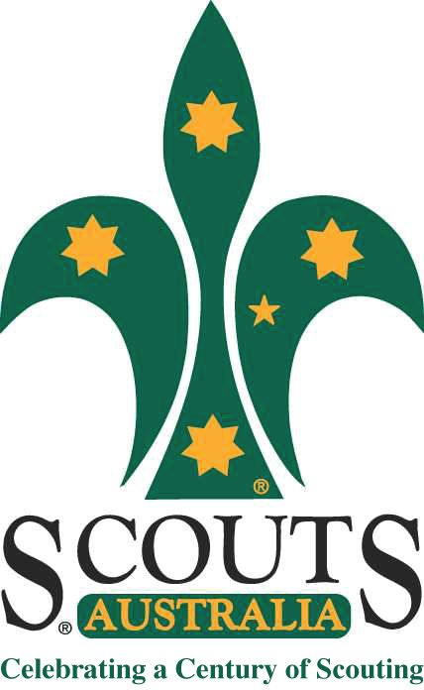
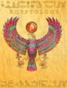
Rosanna Cubs
EGYPTOLOGY!

TUESDAY - 17th Sep!

Time to close off Term 3 and have tons of fun!

Come along and learn how to be an ….. Egyptologist

Dress up as an Egyptian or an Egyptologist (just remember you need to be mobile for our games and activities!) and join in:
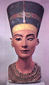
Egyptology!
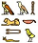

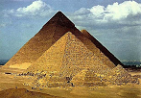
TUESDAY, SEPTEMBER 17th – BE THERE!

Regards

 | Wayne Renfrew, Akela - Rosanna Cubs
 | ph: | (03) 9434 7594 or 0411 121 495
 | email: | akela@rosannacubs.org
 | See us at: | www.rosannacubs.org

Excerpts from “Egyptology” by The Five Mile Press Pty Ltd

