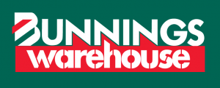

This Tuesday night the Cubs are invited to take their Dads (or Guardian) to Bunnings Northland.

The Cubs will be making Dads a special gift for Father’s Day.
This is a free event and the only thing you need to bring is yourselves (and maybe a smock/apron) Cubs come in full uniform.

The night will commence at 7pm & finish approximately 8:15pm.

See you at 120 Chifley Drive (Corner Murray Road)
Preston VIC 3072 Ph: (03) 9416 6000

Regards
Rahn
