**Rosanna Cubs**

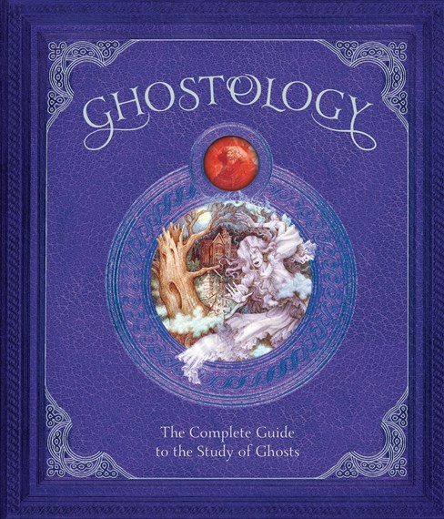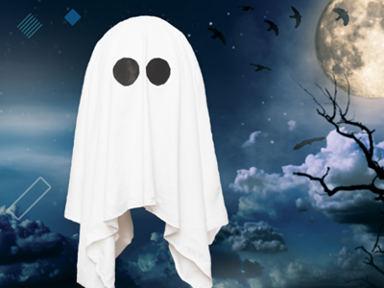

**GHOSTS!**

***TUESDAY - 13th Sep!***

Term 3 is almost over! Must be time for tons of fun!

Come along and immerse yourself in ….. **GHOSTS**

**D**ress up as a Ghost – any type of ghost (no, not yourself – you’re not a Ghost!) – use your imagination to come along as how you think a ghost might look*!*

This is NOT Halloween…. This is Ghosts!

Just remember you need to be mobile for our games and activities! *Then,* you can join in:

**GHOSTS!**

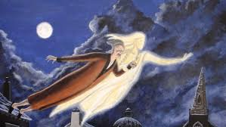

TUESDAY, SEPTEMBER 13th – **BE THERE!**

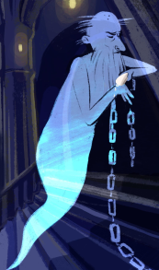

Regards

Akela (Wayne)

[akela@rosannacubs.org](mailto:akela@rosannacubs.org)

0411 121 495

Excerpts from “Ghostology” by Templar Publishing