
Hi Parents

As part of the Centenary of Australian Scouting, Banyule District Scouts will be leading the parade at the Festival in Heidelberg on the 16th. Cubs to be in FULL UNIFORM (white scarf for those not invested). Further details as per below.


Regards
Akela (Wayne)
9434 7594


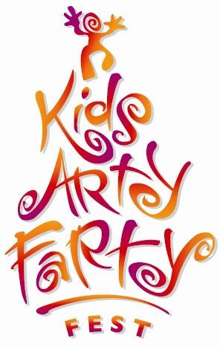
KIDS ARTYFARTY FEST
GRAND PARADE
Sunday 16th March 10am
presented by Heidelberg Central Traders

OUR YARRA RIVER

Date: Sunday 16th March, 2008, 10am (assemble by 9:30am)
Theme: Our Yarra River
Route: Burgundy Street Heidelberg, - Mount Street to Heidelberg Park oval

Assembly details:
Assembly Time: 9:30am to be ready to march at 10:00am.

Assembly point:
Mount Street, Heidelberg, between Burgundy Street and Yarra Street. Look for your Leaders in the Scout section of the parade assembly

Dropping people off:
There will be no vehicle access to Mount Street. If you need to drop people off, enter Yarra Street from either Rosanna Road or Hawdon Street, proceed to Mount Street and turn left. There will be one lane open, heading in the direction of Banksia Street. You can drop people off here. A number of roadblocks will be in place in the area, so please follow these instructions to ensure you arrive in good time

Suggested parking:
Austin Campus multi-deck car park in Martin Street, or Warringal Shopping Centre Car Park, Rosanna Road.

Parade end point:
Note: this year the parade will be ending at Heidelberg Park (across the road from where it has ended previously at Warringal Park). The Parade will enter the car park area and be directed to the assembly areas where the MC will announce the entries as they enter the oval. Keep smiling!

