
Hi Parents

Once again this year, Banyule District Scouts will be taking part in the parade at the Festival in Heidelberg on the 29th. Cubs to be in FULL UNIFORM (white scarf for those not invested). Further details as per below.

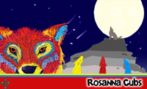
Regards
Akela (Wayne)
9434 7594


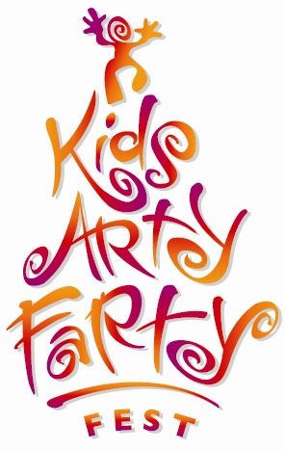
KIDS ARTYFARTY FEST
GRAND PARADE
Sunday 29th March
presented by Heidelberg Central Traders

OUR Magical World

Date: Sunday 29th March, 10am (assemble at 9:30am)
Theme: Our Magical World
Route: Burgundy Street Heidelberg, - Mount Street to Heidelberg Park oval

Assembly details:
Assembly Time: 9:30am to be ready to march at 10:00am.

Assembly point:
Mount Street, Heidelberg, between Burgundy Street and Yarra Street. Look for your Leaders in the Scout section of the parade assembly

Dropping people off:
There will be no vehicle access to Mount Street. If you need to drop people off, enter Yarra Street from either Rosanna Road or Hawdon Street, proceed to Mount Street and turn left. There will be one lane open, heading in the direction of Banksia Street. You can drop people off here. A number of roadblocks will be in place in the area, so please follow these instructions to ensure you arrive in good time

Suggested parking:
Austin Campus multi-deck car park in Martin Street, or Warringal Shopping Centre Car Park, Rosanna Road.

Parade end point:
Follow the parade to the Heidelberg Park / Sills Bend area. Please ensure you pick up your Cubs immediately after the parade ceremonies have ended as Leaders will supervise Cubs until they’re collected

