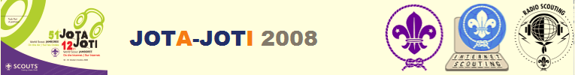
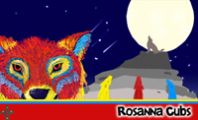
Rosanna Cub Scouts

Jamboree on the Air / Jamboree on the Internet

Each year Scouts of the World communicate via Amateur (Ham) Radio and the Internet. Amateur Radio communications will be running for us this year at:

Clifford Park (Wonga Park – Melway 24 J6)
Saturday October 18
12pm-4:15pm

What will we be doing:
We’ll be doing a number of activities put on specially for the day PLUS of course talking on Amateur radio to Cubs in Victoria, interstate and/or around the World. In other words, we’ll have FUN!

What to bring:
Bring your lunch and, depending on the weather, don’t forget a hat, sunscreen and drink bottle.

To get there:
See http://www.rosannacubs.org/paper.htm and look for “Maps - Clifford Park” and “Clifford Park location - Melway ref 24 J6”

- At Clifford Park (see the link “Map of Clifford Park campsite”) - come through the main gate and park initially at the roundabout near the Warden’s residence… there will likely be special parking provided nearby. If transport is a problem, please let us know!

Please be there at 12pm sharp, so we can have our lunch and quickly get into our activities!

JOTI - JAMBOREE ON THE INTERNET
When you’re at home throughout the weekend, you can also take part in Jamboree on the Internet…. Go to http://www.joti.org - you’ll need to install some chat software if you don’t have it, but the site guides you through that if you would like to give it a go.

Any queries, contact Wayne (Akela)
9434 7594
0411 121 495

