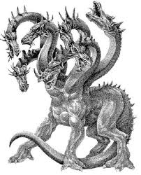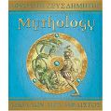Rosanna Cubs
MythOLOGY!

TUESDAY - 4th April!

Term 1 is almost over! Must be time for tons of fun!

Come along and immerse yourself in ….. MythologY

Dress up as a character from Greek Mythology (no, not yourself – you’re not a Greek God!) – use your imagination to come along as an Olympian God, Primordial God, Titan, Giant a Chthonic God, Sea God, Sky God, Zeus, Athena, Medusa, Apollo, Hera, Pandora, Hercules, Artemis, Hermes, Achilles, Hestia, Theseus, Poseidon, Demeter, Ares, Aphrodite, Hephaestus, Dionysus/Bacchus or something else.... there’s thousands to choose from!

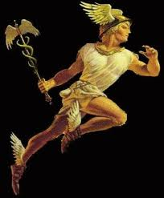Just remember you need to be mobile for our games and activities! Then, you can join in:
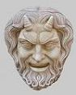 Mythology!

TUESDAY, APRIL 4th – BE THERE!

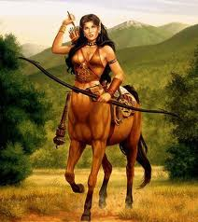Regards

Akela (Wayne)

akela@rosannacubs.org

0411 121 495

Excerpts from “Mythology” by The Five Mile Press Pty Ltd

