

Rosanna Cubs
Pirates!

TUESDAY - 14th August!

Arrr, me hearties! Our final night for Term 3 is here. Time to live the Pirate life and sail the high seas!


Shiver me Timbers, it’s time to be ….. A Pirate!

Dress up as a Pirate, or something to do with pirates. Let’s see how imaginative you (and Mum or Dad!) can be. Just remember you need to be able to be mobile for our games and activities. Then, you can join in:
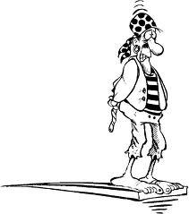
Pirates!



TUESDAY, August 14th – BE THERE

